Introduction: Creating your first mind map
This is a step-by-step guide to creating your first mind map on MindMeister. All basic functions such as formatting, adding icons & images, additional information and sharing maps are covered in this guide.
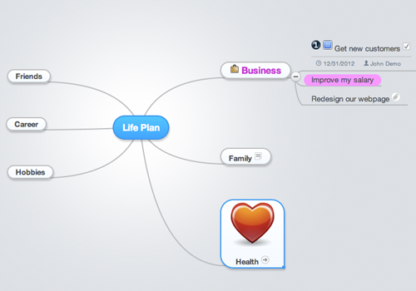
Let's start with a blank map and try to recreate the map shown above.

Create a blank mind map
We'll start by creating a new blank mind map from your map list:
1. Click on "New Mind Map"
2. Select the "Blank" template
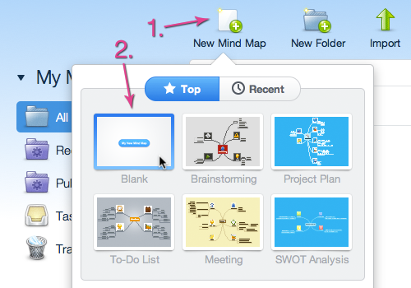
A new mind map will be created and opened in the MindMeister editor.
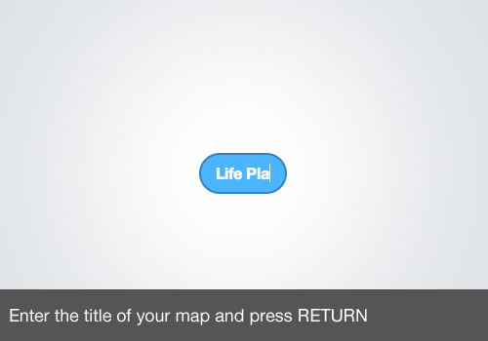
The caption of the root topic will automatically become the title of your mind map when you pressENTER.

Insert your ideas
MindMeister will automatically align topics which are added to the root topic.

Select a topic and press TAB to create a child topic. You can then add sibling topics again when you press ENTER.

Format your ideas
Some topics may be more important to you than others so you might want to highlight them in some way.
We'll now change the color of a topic and increase its font size.
1. Select your topic
2. Click on the larger font size button
3. Open the color palette
4. Switch to the text color tab
5. Select your desired color
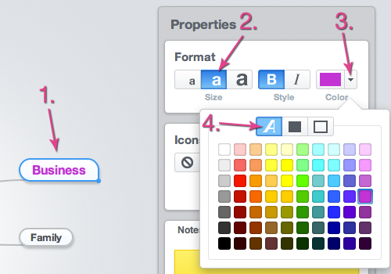
You can change the background color of your topics as well:
1. Select your topic
2. Open the color palette
3. Switch to the background color tab
4. Select your desired color
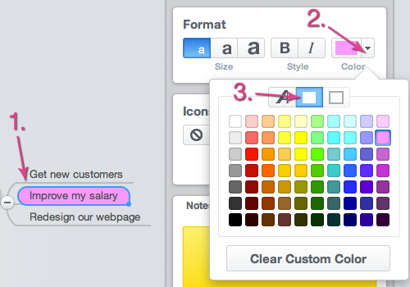
You can choose a different border color as well by selecting the third tab of your color palette.

Add icons & images
You can add icons or images to your topics easily:
1. Select your topic
2. Open the icon menu
3. Select your desired icon
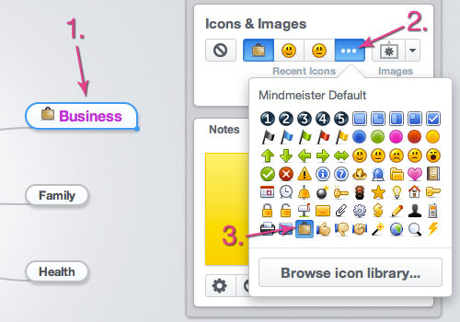
You can choose one of your three recent icons to apply the same icon quicker to different topics.
Applying images to your topics is working the same way:
1. Select your topic
2. Open the image menu
3. Select your desired image
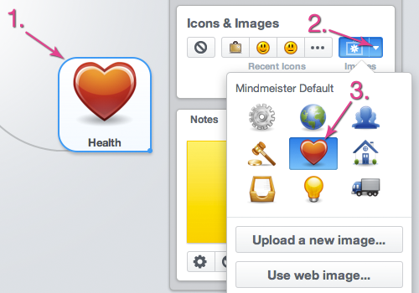
Please click the link below to get more information about icons and images.
Find out more

Add additional information
You can attach important notes, links, files or tasks to any of your topics.
To add notes to your topic:
1. Select your topic
2. Switch to the Notes tab
3. Enter your note
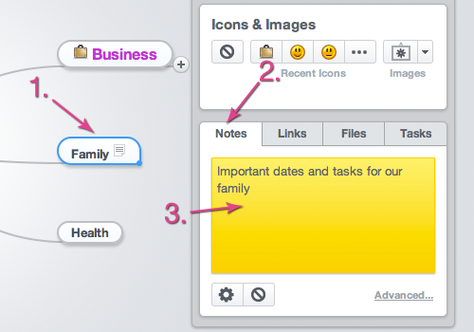
To add links to your topic:
1. Select your topic
2. Switch to the Links tab
3. Enter your URL
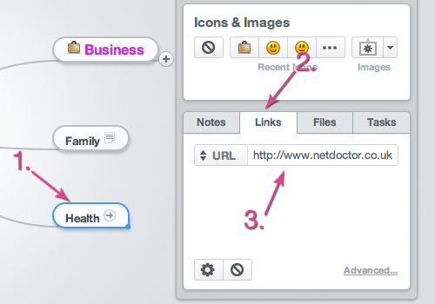
To add files to your topic:
1. Select your topic
2. Switch to the Files tab
3. Click on Upload File...
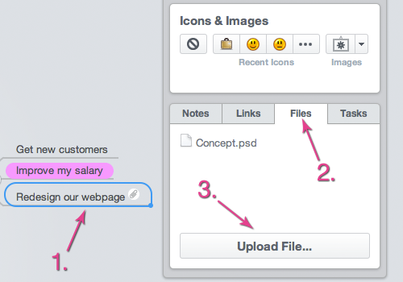
To create a task for your topic:
1. Select your topic
2. Switch to the Tasks tab
3. Set the task information
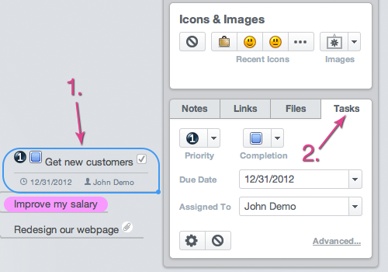
All additional information will be saved automatically.
Please click one of the links below to get more information about advanced features.
Notes Links Files Tasks

Share your map
You now finished your first mind map and maybe want to share it with a friend or colleague.
To share a mind map:
1. Click on private... in your map footer
The following dialog will pop up:
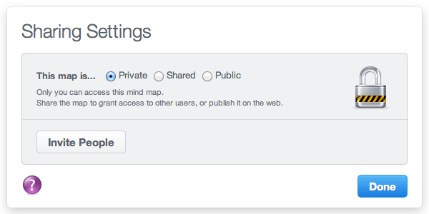
Click on Invite People to share your map:
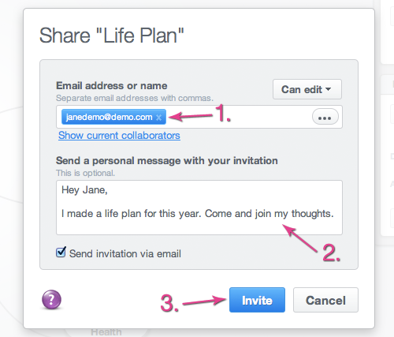
1. Enter the email address of your invitee
2. Add a personal message
Your invitee will then receive an email invitation including a link to access your mind map.
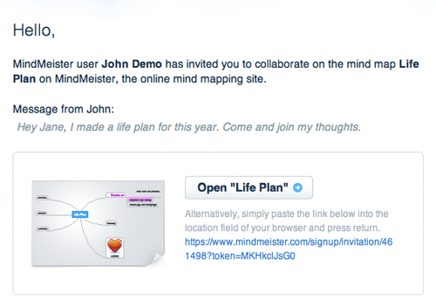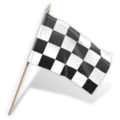

Congratulations, you finished and shared
your first mind map!

Please select a topic to the left or use our search to access specific help topics.

